# Quick Reference

This chapter provides a quick reference source of technical specifications and information for KYMCO Downtown 300i models.

[Component Location](http://www.cyclepedia.com/manuals/KYMCO/CPP-157/Content/Quick%20Reference/Component%20Location.htm) 1-2

[Special Tools](http://www.cyclepedia.com/manuals/KYMCO/CPP-157/Content/Quick%20Reference/Special%20Tools.htm) 1-6

[Specifications](http://www.cyclepedia.com/manuals/KYMCO/CPP-157/Content/Quick%20Reference/Specifications.htm) 1-7

[Torque Specifications](http://www.cyclepedia.com/manuals/KYMCO/CPP-157/Content/Quick%20Reference/Torque%20Specifications.htm) 1-19

[Troubleshooting](http://www.cyclepedia.com/manuals/KYMCO/CPP-157/Content/Troubleshooting.htm) 1-22

[VIN and Engine Number Location](http://www.cyclepedia.com/manuals/KYMCO/CPP-157/Content/Quick%20Reference/VIN%20and%20Engine%20Number%20Location.htm) 1-27

# Component Location

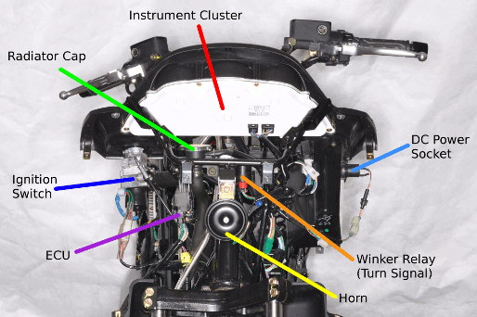

* Instrument Cluster
* Radiator Cap
* DC Power Socket
* Ignition Switch
* ECU
* Winker Relay (Turn Signal Relay)
* Horn

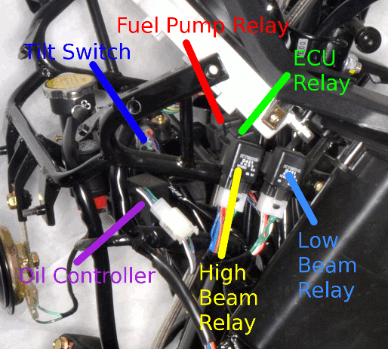

* Fuel Pump Relay
* Tilt Switch
* ECU Relay
* Oil Controller
* High Beam Relay
* Low Beam Relay

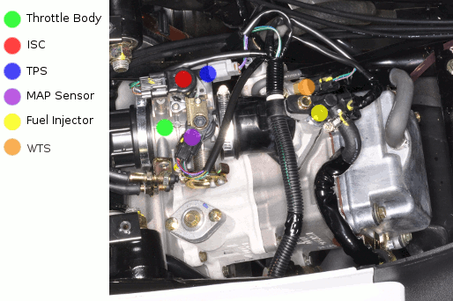

* Throttle Body
* ISC
* TPS
* MAP Sensor
* Fuel Injector
* WTS

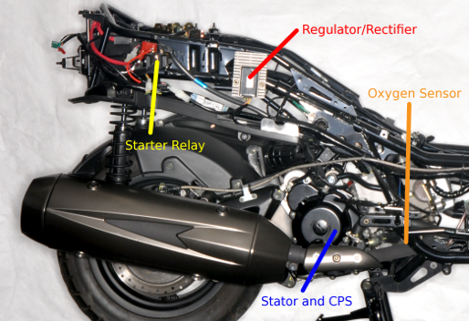

* Regulator/Rectifier
* Starter Relay
* Oxygen Sensor (O2 sensor)
* Stator and Crank Pulse Sensor (Pulser Coil)

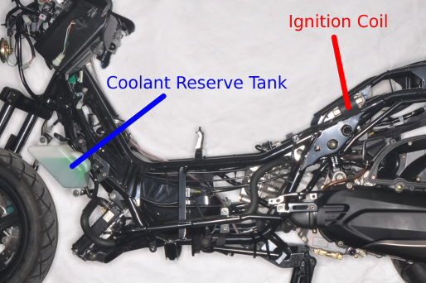

* Ignition Coil
* Coolant Reserve Tank

# Special Tools

|  |  |  |
| --- | --- | --- |
| SPECIAL TOOLS | | |
| ITEM | TOOL NO. | DESCRIPTION |
| FLYWHEEL PULLER | A120E00003 | Flywheel Puller (M28x1) |
| TAPPET ADJUSTER | A120E00012 | Adjusting valve clearance |
| OIL SEAL & BEARING DRIVER | A120E00014 | General Driver Set |
| UNIVERSAL HOLDER | A120E00021 | Holding clutch pulley and flywheel |
| #41 NUT AND FITTING TOOL | A120E00028 | Clutch disassembly |
| THREAD PROTECTOR | A120E00029 | Crankshaft thread protector |
| BEARING PULLER | A120E00037 | General Puller Set |
| VALVE COTTER INSTALLER | A120E00051 | Valve cotter installation |
| CLUTCH SPRING COMPRESSOR | A120E00053 | Clutch disassembly |
| STEERING STEM LOCK NUT WRENCH (32 mm) | F002 | Steering stem removal & installation |

# KYMCO Downtown 200i and 300i Specifications

## General Information

|  |  |  |  |  |  |  |
| --- | --- | --- | --- | --- | --- | --- |
| Name (Model Code) | | | | | | Downtown 300i (LEA7) |
| Name (Model Code) | | | | | | Downtown 200i (SK40AA) |
| Overall length (mm) | | | | | | 2200 |
| Overall width (mm) | | | | | | 800 |
| Overall height (mm) | | | | | | 1410 |
| Wheel base (mm) | | | | | | 1545 |
| Engine type | | | | | | 4 stroke OHC |
| Displacement (cc) | | | | | | 298.9 (300i) 205 cc (200i) |
| Fuel recommended | | | | | | 90 # nonleaded gasoline (300i) 92 # nonleaded gasoline (200i) |
| Curb weight (kg) | | | | Front wheel | | 79 (300i) 70 (200i) |
| Rear wheel | | 110 (300i) 107 (200i) |
| Total | | 189 (300i) 174 (200i) |
| Max. weight capacity (kg) | | | | Front wheel | | 149 |
| Rear wheel | | 205 |
| Total | | 354 |
| Tires | | | | Front wheel | | 120/80-14 58S |
| Rear wheel | | 150/70-13 64S |
| Ground clearance (mm) | | | | | | 140 |
| Performance | | Braking distance (m) | | | | 7.9m / 40 km/hr (300i) 7.9m / 30 km/hr (200i) |
| Min. turning radius (m) | | | | 2.6 |
| Engine | Starting system | | | | | Starting motor |
| Type | | | | | Gasoline, 4-stroke |
| Cylinder arrangement | | | | | SINGLE CYLINDER |
| Combustion chamber type | | | | | Semi-sphere |
| Valve arrangement | | | | | O.H.C. Chain drive |
| Bore x stroke (mm) | | | | | 72.7 x 72 (300i) 66 x 60 (200i) |
| Compression ratio | | | | | 10.8:1 (300i) 10.5:1 (200i) |
| Compression pressure | | | | | 16 (kg/cm2), 228 (psi) |
| Max. Horsepower | | | | | 29 / 7750 PS/rpm (300i) 20.6 / 8000 PS/rpm (200i) |
| Max. Torque | | | | | 2.7 / 6500 Kg-m/rpm (300i) 2.03 / 6500 Kg-m/rpm (200i) |
| Valve timing | | Intake | | Open | - 9.5° BTDC (300i) 5° BTDC (200i) |
| Close | 37.5° ABDC (300i) 32° ABDC (200i) |
| Exhaust | | Open | 40° BBDC (300i) 34° BBDC (200i) |
| Close | 10° ATDC (300i) 5° ATDC (200i) |
| Valve clearance (cold) (mm) | | | Intake | | 0.10 |
| Exhaust | | 0.10 |
| Idle speed (rpm) | | | | | 1600 ± 100 |
| Lubrication System | | Lubrication type | | | Forced pressure & Wet pump |
| Oil pump type | | | Inner/outer rotor type |
| Oil filter type | | | Full-flow filtration |
| Oil capacity | | | 1.5 liter |
| Cooling Type | | | | | Liquid cooling |

|  |  |  |  |  |
| --- | --- | --- | --- | --- |
| Fuel System | Air cleaner type & No | | | Paper element, wet |
| Fuel capacity | | | 12.5 liter |
| Injection | Brand | | Keihin |
| Type | | Throttle body |
| Venturi dia.(mm) | | 34 (300i) 32 (200i) |
| Fuel pump pressure | | 3 Bar |
| Electrical Equipment | Ignition System | Type | | ECU |
| Ignition timing | | 10° BTDC at idle to  33° at 6500 rpm (300i) 4° BTDC at idle to  32° at 6500 rpm (200i) |
| Spark plug | Spec. | CR7E (NGK) |
| Gap | 0.6-0.7 mm |
| Battery Capacity | | | 12V10AH |
| Power Drive System | Clutch Type | | | Dry multi-clutch |
| Transmission Gear | Type | | CVT |
| Operation | | Automatic centrifugal type |
| Reduction Gear | Type | | Two-stage reduction |
| Reduction ratio | 1st | 2.24 ~ 0.72 (300i) 2.57 ~ 0.81 (200i) |
| 2nd | 7.222 (300i) 9.54 (200i) |
| Moving Device | Tire type | | | Tubeless |
| Wheel material | | | Aluminum |
| Tire pressure  Kg/cm2 (psi) | | Front | 2.0 (28.4) |
| Rear | 2.25 (32) |
| Handle turning angle(L/R) | | Left | 40° |
| Right | 40° |
| Brake system type | | | Front | Disc brake |
| Rear | Disc brake |
| Damping Device | Suspension type | | Front | Telescope |
| Rear | Swing arm |
| Shock absorber stroke | | Front | 110 mm |
| Rear | 100 mm |
| Frame type | | | | UNDER BONE |

|  |  |  |
| --- | --- | --- |
| ENGINE | | |
| Throttle grip free play | 2 ~ 6 mm | |
| Spark plug | NGK: CR7E | |
| Spark plug gap | 0.6 mm ~ 0.7 mm | |
| Valve clearance | IN: 0.10 mm | EX: 0.10 mm |
| Idle speed | 1600 ± 100 rpm | |
| Cylinder compression | 16 ± 2 kg/cm2 | 228 ± 28.4 psi |
| Ignition timing | ECU | |
| Coolant type | Coolant type | |
| Engine oil capacity: | | |
| At disassembly | 1.5 Liter | |
| At change | 1.3 Liter | |
| Gear oil type: | SAE 90 | |
| Gear oil capacity: | | |
| At disassembly | 0.23 Liter | |
| At change | 0.21 Liter | |

|  |  |
| --- | --- |
| Coolant capacity: | |
| Radiator | 766 cc |
| Hose with cool coolant | 169 cc |
| Hose with hot coolant | 194 cc |
| Reserve tank | 590 cc |
| Total capacity | 1719 cc |

## Engine

|  |  |  |
| --- | --- | --- |
| Item | | Standard (mm) |
| Valve clearance (cold) | IN | 0.10 |
| EX | 0.10 |
| Cylinder head compression pressure | | 16 kg/cm2, 228 psi |
| Camshaft cam height | IN | 34.2987 |
| EX | 34.1721 |
| Valve rocker arm I.D. | IN | 10.00 - 10.015 |
| EX | 10.00 - 10.015 |
| Valve rocker arm shaft O.D. | IN | 9.972 - 9.987 |
| EX | 9.972 - 9.987 |
| Valve seat width | IN | 1.2 |
| EX | 1.2 |
| Valve stem O.D. | IN | 4.990 - 4.975 |
| EX | 4.970 - 4.955 |
| Valve guide I.D. | IN | 5.00 - 5.012 |
| EX | 5.00 - 5.012 |
| Valve stem-to-guide clearance | IN | 0.010 - 0.037 |
| EX | 0.030 - 0.057 |

|  |  |  |  |
| --- | --- | --- | --- |
| Item | | | Standard (mm) |
| Cylinder | I.D. | | 72.7 |
| Taper limit | | 0.05 |
| Out of round limit | | 0.05 |
| Piston,  piston ring | Ring-to-groove clearance | Top | 0.015 - 0.055 |
| Second | 0.015 - 0.055 |
| Ring end gap | Top | 0.10 - 0.25 |
| Second | 0.10 - 0.25 |
| Oil side rail | 0.2 - 0.7 |
| Piston O.D. | |  |
| Piston O.D. measuring point | | 9 mm from bottom of skirt |
| Piston-to-cylinder clearance | | 0.101 - 0.040 |
| Piston pin hole I.D. | | 15.002 - 15.008 |
| Piston pin O.D. | | | 14.994 - 15.000 |
| Piston-to-piston pin clearance | | | 0.002 - 0.014 |
| Connecting rod small end I.D. Bore | | | 15.016 - 15.034 |

|  |  |  |  |
| --- | --- | --- | --- |
| Item | | Standard (mm) | Service Limit (mm) |
| Crankshaft | Connecting rod big  end side clearance | 0.15 - 0.35 | 0.6 |
| Connecting rod big  end radial clearance | 0 - 0.008 | 0.05 |

|  |  |  |  |  |
| --- | --- | --- | --- | --- |
| Bearing Color | | | | |
|  | Crankcase mark | | | |
| Crankshaft mark | A | B | C | D |
| A | black | green | green | red |
| B | green | green | red | --- |

|  |  |
| --- | --- |
| Item | Service Limit (mm) |
| Starter drive gear I.D. | 22.15 |
| Starter drive gear O.D. | 41.50 |

## CVT

|  |  |  |
| --- | --- | --- |
| Item | Standard (mm) | Service Limit (mm) |
| Clutch lining thickness | 4.0 | 2.0 |
| Clutch outer I.D. | 152.1 - 152.2 | 152.2 |
| Weight roller O.D (Drive Pulley) | 19.92 - 20.08 | 20.08 |

## Cooling System

|  |  |  |  |
| --- | --- | --- | --- |
| Radiator cap relief pressure | | 0.9 ± 0.15 kg/cm2 (12.8 ± 2.1 psi) | |
| Thermostat temperature | Begins to open | 71 °C | |
| Full-open | 80 °C | |
| Valve lift | 3.5 - 4.5 mm | |
| Coolant capacity | | Total 1719 cc | Radiator: 766 cc  Reserve tank: 590 cc  Hose: 363 cc |

|  |  |  |  |
| --- | --- | --- | --- |
| COOLANT MIXTURE (WITH ANTI-RUST AND ANTI-FREEZING EFFECTS) | | | |
| Freezing Point | Mixing Rate | KYMCO SIGMA Coolant Concentrate | Distilled Water |
| -9°C | 20% | 344 cc | 1375 cc |
| -15°C | 30% | 516 cc | 1203 cc |
| -25'°C | 40% | 688 cc | 1031 cc |
| -37°C | 50% | 860 cc | 859 cc |
| -44.5°C | 55% | 945 cc | 774 cc |

|  |  |  |  |  |  |  |
| --- | --- | --- | --- | --- | --- | --- |
| COOLANT GRAVITY CHART | | | | | | |
| Temp. C°  Coolant concentration | 0 | 5 | 10 | 15 | 20 | 25 |
| 5% | 1.009 | 1.009 | 1.008 | 1.008 | 1.007 | 1.006 |
| 10% | 1.018 | 1.107 | 1.017 | 1.016 | 1.015 | 1.014 |
| 15% | 1.028 | 1.027 | 1.026 | 1.025 | 1.024 | 1.022 |
| 20% | 1.036 | 1.035 | 1.034 | 1.033 | 1.031 | 1.029 |
| 25% | 1.045 | 1.044 | 1.043 | 1.042 | 1.040 | 1.038 |
| 30% | 1.053 | 1.051 | 1.051 | 1.049 | 1.047 | 1.045 |
| 35% | 1.063 | 1.062 | 1.060 | 1.058 | 1.056 | 1.054 |
| 40% | 1.072 | 1.070 | 1.068 | 1.066 | 1.064 | 1.062 |
| 45% | 1.080 | 1.078 | 1.076 | 1.074 | 1.072 | 1.069 |
| 50% | 1.086 | 1.084 | 1.082 | 1.080 | 1.077 | 1.074 |
| 55% | 1.095 | 1.093 | 1.091 | 1.088 | 1.085 | 1.082 |
| 60% | 1.100 | 1.098 | 1.095 | 1.092 | 1.089 | 1.086 |

|  |  |  |  |  |  |
| --- | --- | --- | --- | --- | --- |
| Temp. C°  Coolant  concentration | 30 | 35 | 40 | 45 | 50 |
| 5% | 1.005 | 1.003 | 1.001 | 0.009 | 0.997 |
| 10% | 0.013 | 1.011 | 1.009 | 1.007 | 1.005 |
| 15% | 1.020 | 1.018 | 1.016 | 1.014 | 1.012 |
| 20% | 1.027 | 1.025 | 1.023 | 1.021 | 1.019 |
| 25% | 1.036 | 1.034 | 1.031 | 1.028 | 1.025 |
| 30% | 1.043 | 1.041 | 1.038 | 1.035 | 1.032 |
| 35% | 1.052 | 1.049 | 1.046 | 1.043 | 1.040 |
| 40% | 1.059 | 1.056 | 1.053 | 1.050 | 1.047 |
| 45% | 1.056 | 1.063 | 1.062 | 1.057 | 1.054 |
| 50% | 1.071 | 1.068 | 1.065 | 1.062 | 1.059 |
| 55% | 1.079 | 1.076 | 1.073 | 1.070 | 1.067 |
| 60% | 1.083 | 1.080 | 1.077 | 1.074 | 1.071 |

## Fuel Injection System

|  |  |  |
| --- | --- | --- |
| ITEM | | SPECIFICATIONS |
| Throttle body identification number | | LEA7 |
| Idle speed | | 1600 ± 100 rpm |
| Throttle grip free play | | 2 - 6 mm (1/16 - 1/4 in) |
| Fuel injector resistance (at 20°C/68°F) | | 9.9 - 13.5 Ω |
| Fuel pump resistance (at 20°C/68°F) | Float at full position | 1100 ± 33 Ω |
| Float at empty position | 100 ± 3 Ω |
| Fuel pump standard pressure (at 40 L/Hr) | | 3 Bar 294 ± 6 kPa 42 ± 0.9 psi |
| Water temperature sensor resistance | At -20°C/-4°F | 18.8 KΩ |
| At 40°C/104°F | 1.136 KΩ |
| At 100°C/212°F | 0.1553 KΩ |
| Intake pressure sensor (MAP) pressure (at 1 - 4.2 V) | | 13.332 kPa (0.13332 kgf/ cm2, 1.89 psi) - 119.99 KPa (1.1999 kgf/ cm2, 17.04 psi) |
| Inductive ignition coil | | Primary: 3.57 - 4.83 Ω Secondary: 10.42~14.49 KΩ |
| Throttle position sensor (TPS) resistance (at 20°C/68°F) | | 3500 - 6500 Ω |
| Crank position sensor voltage (at 200 rpm) | | 100 - 130 Ω |
| O2 heater sensor resistance (at 20°C/68°F) | | 6.7 - 9.5 Ω (engine warming condition) |
| Tilt switch voltage | Standard | 0.4 - 1.4 V |
| Over 65° (fall down) | 3.7 - 4.4 V |

|  |  |  |  |  |
| --- | --- | --- | --- | --- |
| CELP FAILURE CODES LIST | | | | |
| Blinks | Failure Codes | Contents | Causes | Symptoms |
| 06 | P0120 | Faulty TPS | • Faulty TPS voltage range (0.3 - 4.5 V) • Loose or poor connection on TPS Sensor  • Open or short circuit on the TPS wire  • Faulty TPS itself. | Engine operates normally |
| 09 | P0105 | Faulty MAP | • Faulty MAP voltage range (1 - 4.2 V) • Loose or poor connection on MAP Sensor • Open or short circuit on MAP wire • Faulty MAP itself | Engine operates normally |
| 12 | P0115 | Faulty WTS (water temp.) | • Faulty ECT Ω range (-20°C: 18.8 Ω/40°C: 1.136 Ω/100°C: 0.1553 Ω) • Loose or poor connection on ECT • Open or short circuit on ECT wire • Faulty ECT | Engine operates normally |
| 15 | P1630 | Faulty Tilt switch (Roll) | • Faulty Tilt switch voltage range (inclined angle <65°: 0.4 - 1.4 V/ Inclined angle >65°: 3.7 - 4.4 V) • Loose or poor connection on Tilt switch • Open or short circuit in Tilt switch wire • Faulty tilt switch | Engine operates normally |
| 17 | P0130 | Faulty  O2sensor | • Faulty O2 sensor voltage range (A/F below 14.7: > 0.7V/ A/F over 14.7: < 0.18 V)  • Loose or poor connection on O2sensor  • Open or short circuit on O2 sensor wire  • Faulty O2 sensor | Engine operates normally |
| 33 | P0201 | Faulty injector (Nozzle) | • Faulty Fuel injector Ω range (9.945 - 13.5 Ω)  • Loose or poor connection on injector  • Open or short circuit on injector wire  • Faulty fuel injector | Engine fails to be operated |
| 37 | P0351 | Faulty inductive ignition coil | • Faulty Inductive ignition coil Ω range (4.2 Ω ± 15%)  • Loose or poor connection on inductive ignition coil  • Open or short circuit on inductive ignition coil wire  • Faulty inductive ignition coil | Engine fails to be operated |
| 41 | P0230 | Faulty fuel pump | • Faulty Fuel pump fl range (F: 1100 ± 33 Ω E: 100 + 3 Ω)  • Loose or poor connection on fuel pump  • Open or short circuit on fuel pump wire  • Faulty fuel pump | Engine fails to be operated |
| 45 | P0135 | Faulty  O2sensor heater | • Faulty O2 sensor heater Ω range (6.7 -9.5 Ω)  • Loose or poor connection on O2sensor heater  • Open or short circuit on O2 sensor heater wire  • Faulty O2 sensor heater | Engine starts normally but not smooth |
| 49 | P1505 | Faulty ISC | • Loose or poor contacts on ISC  • Open or short circuit in ISC wire  • Faulty ISC | Engine operates normally |
| 66 | P0335 | Faulty CPS | • Loose or poor connection on CPS sensor  • Open or short circuit on CPS wire  • Faulty CPS sensor | Engine starts normally but not smooth |

## Axle/Brakes/Wheels

|  |  |  |
| --- | --- | --- |
| Item | Standard mm (in) | Service Limit |
| Axle shaft runout | — | 0.2 mm  (0.008 in) |
| Brake disk thickness (front) | 3.8 - 4.2 (0.15 - 0.165) | 0.3 mm (0.012 in) |
| Brake disk thickness (rear) | 5.0 (0.2) | — |
| Brake disk runout | — | 0.4 mm |
| Brake master cylinder I.D. | 12.7 - 12.74 (0.508 - 0.5096) | — |
| Brake master cylinder piston O.D. | 12.65 - 12.68  (0.506 - 0.5072) | — |
| Front brake caliper piston O.D. | 26.93 - 26.96 (1.0602 - 1.0614) | — |
| Front brake caliper cylinder I.D. | 27 - 27.05  (1.063 - 1.065) | — |

|  |  |
| --- | --- |
| Item | Standard (mm) |
| Wheel rim runout service limit | max 5 |
| Rear brake disk thickness | 5.0 |
| Rear brake disk runout | max 0.4 |
| Rear brake caliper piston O.D. | 25.33 - 25.36 |
| Rear brake caliper cylinder I.D. | 25.40 - 25.45 |

## Electrical

|  |  |  |  |
| --- | --- | --- | --- |
| Item | | | Standard |
| Battery | Capacity | | 12V 10AH |
| Voltage (20°C) | Fully charged | 13.2V |
| Insufficient charged | < 12.3V |
| Charging current | | 1.2A* 5 - 10H |

|  |  |  |
| --- | --- | --- |
| Item | | Standard |
| Spark plug | Standard type | NGKCR7E |
| Spark plug gap | | 0.6 - 0.7 mm |
| Inductive Ignition Coil | Primary coil | 3.57 - 4.83 Ω |
| Secondary coil without plug cap | 10.42 - 14.49 KΩ |
| Throttle Position Sensor | | 3500 - 6500 Ω |
| Fuel Pump | | 1.9 Ω approx. |
| Fuel Injector | | 11.7 ± 0.6 Ω |
| Water Temperature Sensor | | 2.076 KΩ ± 10% (25°C) |
| Oxygen Sensor ( engine warming condition ) | | 6.7 Ω - 9.5 Ω |
| Crank Position Sensor | | 115 Ω ± 15 Ω |
| Tilt Switch | | 0.4V - 1.4V(normal)  3.7V - 4.4V (fall down) |

|  |  |  |
| --- | --- | --- |
| Water temperature sensor resistance | At -20°C/-4°F | 18.8 KΩ |
| At 40°C/104°F | 1.136 KΩ |
| At 100°C/212°F | 0.1553 KΩ |

|  |  |  |
| --- | --- | --- |
| Item | Standard | Service Limit |
| Starter motor brush length | 12.5 mm | 8.5 mm |

|  |  |
| --- | --- |
| Fuse | 10A,15A,30A |
| Headlight bulb | 12V 35W/35W *2 |
| Turn signal light bulb | 12V 21 W(Front) / 10W(Rear) |
| Stoplight/taillight | 12V21/5W |

# Torque Specifications

|  |  |  |  |  |  |
| --- | --- | --- | --- | --- | --- |
| ENGINE | | | | | |
| **Item** | **Qty** | **Thread  size (mm)** | **Torque** | | **Remarks** |
| **kgf-m** | **lb-ft** |
| Cylinder head stud bolt: |  |  |  |  |  |
| 1. Stud bolt (Inlet pipe side) | 2 | 6 | 0.7-1.1 | 5.06-7.96 | Double end bolt |
| 2. Stud bolt (EX pipe side) | 2 | 8 | 0.7-1.1 | 5.06-7.96 | Double end bolt |
| Cylinder head stud nut | 4 | 10 | 3.4-3.8 | 24.59-27.48 |  |
| Right crankcase cover bolt | 15 | 6 | 1.0-1.4 | 7.23-10.13 |  |
| Left crankcase cover bolt | 15 | 6 | 1.0-1.4 | 7.23-10.13 |  |
| Transmission case bolts | 9 | 8 | 0.8-1.2 | 1.7-2.6 |  |
| Bolt B stud 10*180 | 4 | 10 | 1.0-1.4 | 7.23-10.13 | Apply oil to thread |
| Valve adjusting lock nut | 4 | 5 | 0.7-1.1 | 5.06-7.96 | Apply oil to thread |
| Cam sprocket bolt | 2 | 6 | 1.0-1.4 | 7.23-10.13 | Apply thread lock |
| Camshaft set plate bolt | 1 |  | 1.2 | 2.0 | Apply thread lock |
| Final drive oil check\drain bolt | 2 | 8 | 0.8-1.2 | 5.79-8.68 |  |
| Engine oil drain bolt | 1 | 12 | 2.0-3.0 | 14.47-21.70 |  |
| Engine oil strainer cap | 1 |  | 1.02 | 7.2 |  |
| Clutch outer nut (driven pulley) | 1 | 12 | 5.0-6.0 | 36.17-43.40 |  |
| Starter motor mounting bolt | 2 | 6 | 1.0-1.4 | 7.23-10.13 |  |
| Mission case bolt | 6 | 8 | 1.8-2.2 | 13.02-15.91 |  |
| Drive face nut | 1 | 14 | 9.0-10.0 | 65.10-72.33 | Apply oil to thread |
| Clutch drive plate nut | 1 |  | 7.5 | 55.32 |  |
| Drive plate comp | 1 | 28 | 5.0-6.0 | 36.17-43.40 |  |
| Cam chain tensioner bolt | 2 | 6 | 1.0-1.4 | 7.23-10.13 |  |
| Cam chain tensioner pivot | 1 | 8 | 0.8-1.2 | 5.79 - 8.68 |  |
| Oneway clutch bolt | 3 | 8 | 1.8-2.2 | 13.02-15.91 | Apply thread lock |
| ACG flywheel nut | 1 | 14 | 5.5-6.5 | 39.78-47.01 |  |
| Spark plug | 1 | 12 | 1.5-2.0 | 10.84-14.47 |  |
| Water pump impeller | 1 | 7 | 1.0-1.4 | 7.23-10.13 | Left thread |
| Water pump cover bolts | 4 | 6 | 1.0-1.4 | 7.23-10.13 |  |

|  |  |  |  |  |  |
| --- | --- | --- | --- | --- | --- |
| FRAME | | | | | |
| **Item** | **Qty** | **Thread  size (mm)** | **Torque** | | **Remarks** |
| **kgf-m** | **lb-ft** |
| Steering: |  |  |  |  |  |
| 1. Stem lock nut | 1 | BC1 | 6.0-8.0 | 43.40-57.86 |  |
| 2. Handle post bolt | 1 | 10 | 4.0-5.0 | 28.93-36.17 | U-nut |
| 3. Bridge bolt | 1 | 8 | 2.4-3.0 | 17.36-21.70 |  |
| 4. Race nut (head) | 1 | BC1 | 1.8-2.2 | 13.02-15.91 |  |
| Brake: |  |  |  |  |  |
| 1. Front/Rear caliper bolt | 1 | 10 | 3.0-4.0 | 21.70-28.93 |  |
| 2. Brake hose bolt | 1 | 10 | 3.0-4.0 | 21.70-28.93 |  |
| 3. Disk bolt | 5 | 8 | 3.2-3.8 | 23.15-27.48 |  |
| Engine hanger: |  |  |  |  |  |
| 1. Frame side | 2 | 14 | 6.0-7.0 | 43.40-50.63 | U-nut |
| 2. Engine side | 1 | 10 | 4.5-5.5 | 32.55-39.78 | U-nut |
| Rear fork bolt | 2 | 10 | 3.0-4.0 | 21.70-28.93 |  |
| Speed sensor cable | 1 | 6 | 1.0-1.4 | 7.23-10.13 |  |
| 02 sensor | 1 | 12 | 2.0-3.0 | 14.47-21.70 |  |
| Rear carrier | 4 | 8 | 2.0-2.8 | 14.47-20.25 |  |
| Front axle | 1 | 14 | 1.5-2.5 | 10.84-18.08 |  |
| Rear axle nut | 1 | 16 | 11-13 | 79.56-94.03 | U-nut |
| Rear cushion upper/lower bolt | 1 | 10 | 3.5-4.5 | 25.32-32.55 |  |
| Suspension: |  |  |  |  |  |
| Shock absorber mounting bolt |  |  | 4 | 28.93 |  |
| Fuel Pump Bolts | 6 |  | 0.35 | 2.5 |  |

## General Torque Specifications

|  |  |  |
| --- | --- | --- |
| Item | Torque | |
| kgf-m | lb-ft |
| 5 mm bolt, nut | 0.45 - 0.6 | 3.25 - 4.34 |
| 6 mm bolt, nut | 0.8 - 1.2 | 5.79 - 8.68 |
| 8 mm bolt, nut | 1.8 - 2.5 | 13.02 - 18.08 |
| 10 mm bolt, nut | 3.0 - 4.0 | 21.70 - 28.93 |
| 12 mm bolt, nut | 5.0 - 6.0 | 36.17 - 43.40 |
| 5 mm screw | 0.45 - 0.6 | 3.25 - 4.34 |
| 6 mm screw, SH bolt | 0.7 - 1.1 | 5.06 - 7.96 |
| 6 mm flange bolt, nut | 1.0 - 1.4 | 7.23 - 10.13 |
| 8 mm flange bolt, nut | 2.4 - 3.0 | 17.36 - 21.70 |
| 10 mm flange bolt, nut | 3.0 - 4.5 | 21.70 - 32.55 |

# Troubleshooting

## Vehicle can not be started

### Preliminary 6 Step Inspection

1. Is the battery fully charged (12 V or higher). See the [Battery](http://www.cyclepedia.com/manuals/KYMCO/CPP-157/Content/Electrical%20Systems/Battery.htm) topic for more information.

2. Key-On and listen for any action with Fuel Pump / Fuel Pump Relay (It will turn off automatically in 5-10 seconds)

3. Key-On to check for any failure lamp light up on dashboard. See the[Self-Diagnosis](http://www.cyclepedia.com/manuals/KYMCO/CPP-157/Content/Electrical%20Systems/Self-Diagnosis.htm) topic for more information.

4. Is the Idle screw of Throttle Valve being changed or loose?

5. Has the vehicle under regular service? Is the gas station a good one?

6. Is the spark plug the correct model of specified by the vehicle builder? See the [Spark Plug](http://www.cyclepedia.com/manuals/KYMCO/CPP-157/Content/Periodic%20Maintenance/Spark%20Plugs.htm) topic for more information.

## Troubleshooting by section

* [Brakes](http://www.cyclepedia.com/manuals/KYMCO/CPP-157/Content/Brakes/Brakes.htm#TROUBLES)
* [Cooling System](http://www.cyclepedia.com/manuals/KYMCO/CPP-157/Content/Cooling%20System/Cooling%20System.htm#TROUBLES)
* [CVT Continuously Variable Transmission](http://www.cyclepedia.com/manuals/KYMCO/CPP-157/Content/CVT/CVT.htm#TROUBLES)
* [Electrical Systems](http://www.cyclepedia.com/manuals/KYMCO/CPP-157/Content/Electrical%20Systems/Electrical%20Systems.htm#TROUBLES)
* [Engine](http://www.cyclepedia.com/manuals/KYMCO/CPP-157/Content/Engine/Engine.htm#TROUBLES)
* [Final Drive](http://www.cyclepedia.com/manuals/KYMCO/CPP-157/Content/Final%20Drive/Final%20Drive.htm#TROUBLES)
* [Front Suspension](http://www.cyclepedia.com/manuals/KYMCO/CPP-157/Content/Front%20Suspension/Front%20Suspension.htm)
* [Fuel Injection System](http://www.cyclepedia.com/manuals/KYMCO/CPP-157/Content/Fuel%20System/Fuel%20System.htm#TROUBLES)
* [Rear Suspension](http://www.cyclepedia.com/manuals/KYMCO/CPP-157/Content/Rear%20Suspension/Rear%20Suspension.htm#TROUBLES)
* [Steering](http://www.cyclepedia.com/manuals/KYMCO/CPP-157/Content/Steering/Steering.htm)
* [Wheels](http://www.cyclepedia.com/manuals/KYMCO/CPP-157/Content/Wheels/Wheels.htm#Troubles)

## General Troubleshooting

[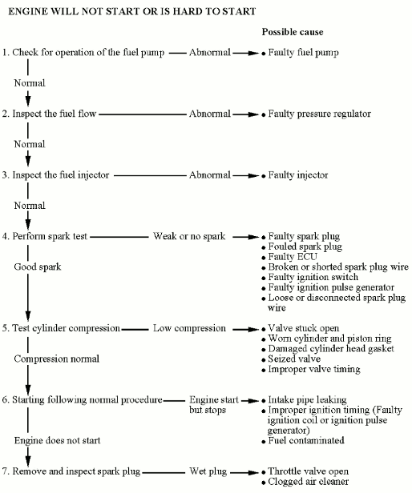](http://www.cyclepedia.com/manuals/KYMCO/CPP-157/Content/Resources/Images/TS-ES.png)

[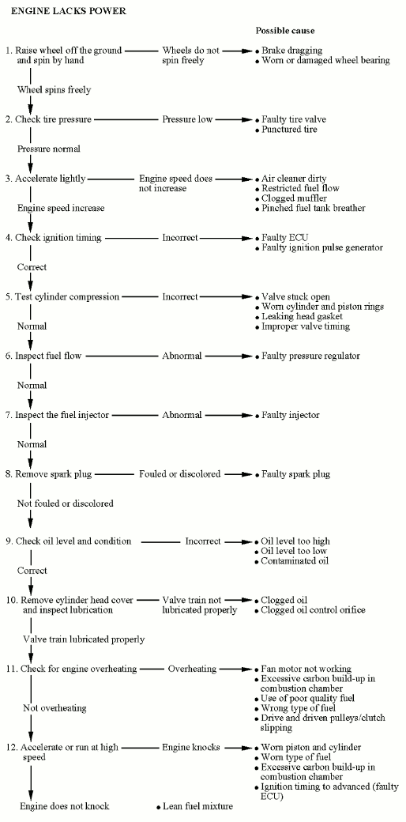](http://www.cyclepedia.com/manuals/KYMCO/CPP-157/Content/Resources/Images/TS-ELP.png)

[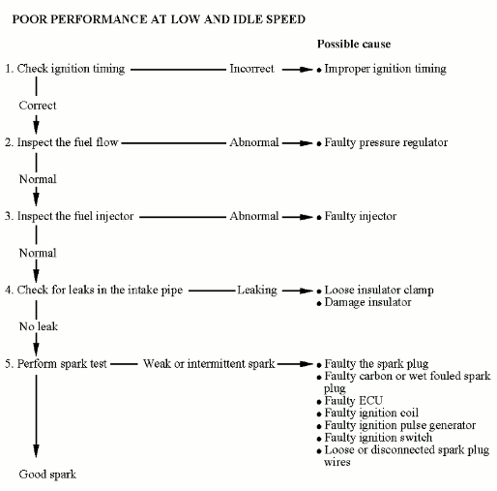](http://www.cyclepedia.com/manuals/KYMCO/CPP-157/Content/Resources/Images/TS-PPI.png)

[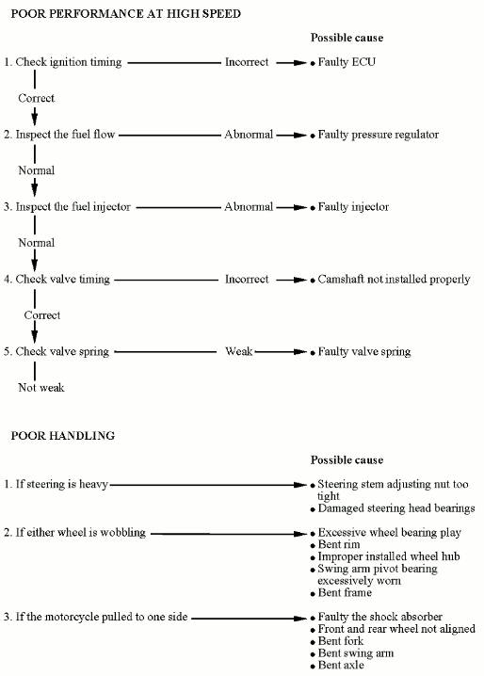](http://www.cyclepedia.com/manuals/KYMCO/CPP-157/Content/Resources/Images/TS-PPS.png)

# VIN and Engine Number Location

[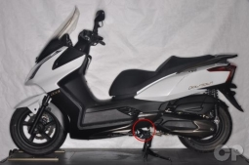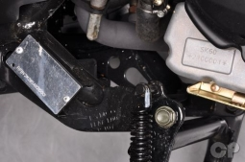](javascript:void(0);)

The VIN is stamped on a plate on the lower right side.

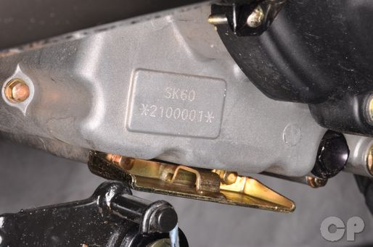

The engine serial number is stamped on bottom of the left crankcase.

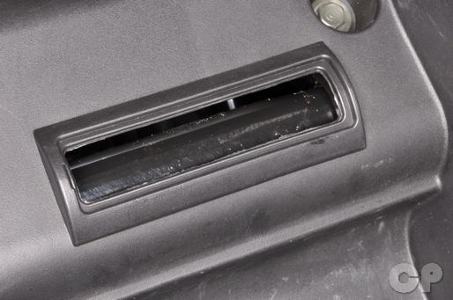

The VIN is also stamped on the frame inside of the luggage box.